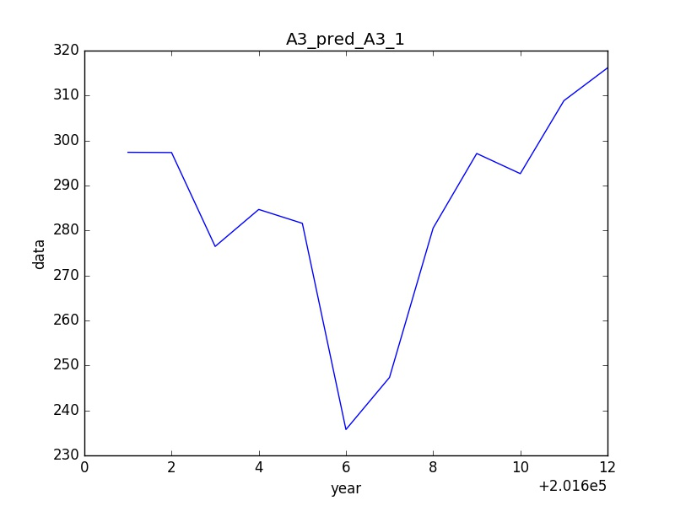

201601: 297.387040044

201602: 297.338653353

201603: 276.461195778

201604: 284.684699341

201605: 281.602107366

201606: 235.751433269

201607: 247.345597846

201608: 280.53506885

201609: 297.125471326

201610: 292.642911031

201611: 308.863895464

201612: 316.15087526

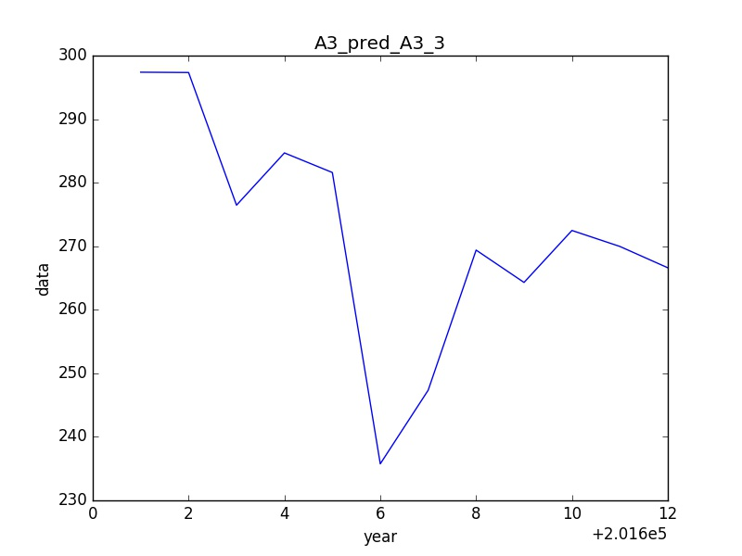

201601: 297.387040044

201602: 297.338653353

201603: 276.461195778

201604: 284.684699341

201605: 281.602107366

201606: 235.751433269

201607: 247.345597846

201608: 269.393195526

201609: 264.302287138

201610: 272.479871801

201611: 269.965260612

201612: 266.607943266

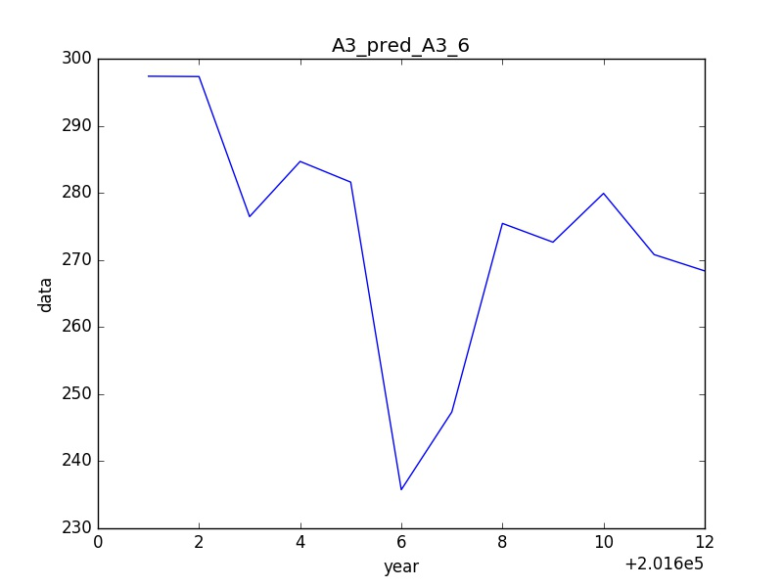

201601: 297.387040044

201602: 297.338653353

201603: 276.461195778

201604: 284.684699341

201605: 281.602107366

201606: 235.751433269

201607: 247.345597846

201608: 275.449072422

201609: 272.650008726

201610: 279.92707904

201611: 270.799504783

201612: 268.369284393